**Pizza Sales Queries**

1. KPI’s
2. Total Revenue.

select Sum(total_price) As Total_Revenue from pizza_sales;

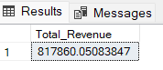

2. Average_order_value

select Sum(total_price) / Count(Distinct order_id) as Avg_order_value from pizza_sales;

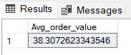

3. Total Pizzas Sold

select Sum(quantity)As Total_pizza_sold from pizza_sales;

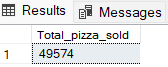

4. Total Orders

select Count(Distinct order_id) as Total_orders from pizza_sales;

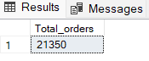

5. Average Pizzas per order

select Cast(Cast(Sum(quantity) As decimal (10,2)) / Cast(Count(Distinct order_id) As decimal (10, 2)) As decimal (10,2)) As Avg_Pizzas_per_order from pizza_sales;

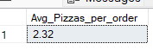

1. Daily and Monthly Trend

6. Daily Trend for Total Orders

select DATENAME(DW, order_date) as order_day, Count(Distinct order_id) as Total_orders from pizza_sales Group By DATENAME(DW, order_date);

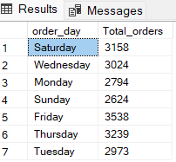

7. Monthly Trend for Total Orders

select DATENAME(MONTH, order_date) as Month_name, Count(Distinct order_id) from pizza_sales Group By DATENAME(MONTH, order_date);

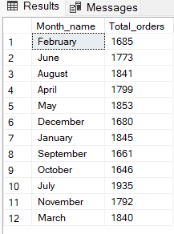

8. Percentage of sales % by Pizza Category

select pizza_category,sum(total_price) as Total_Sales,Sum(total_price)*100 / (Select Sum(total_price) From pizza_sales Where Month(order_date) = 1) As PCT From pizza_sales Where Month(order_date) = 1 Group By pizza_category;

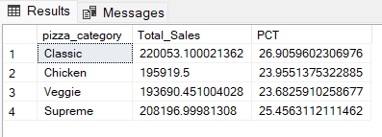

9. Percentage of Sales by Pizza Size

select pizza_size,Cast(sum(total_price)AS Decimal (10, 2)) as Total_Sales, Cast(Sum(total_price)*100 / (Select Sum(total_price) From pizza_sales Where Datepart (quarter, order_date) = 1) As Decimal (10, 2)) As PCT From pizza_sales Where Datepart (quarter, order_date) = 1 Group By pizza_size Order By PCT Desc;

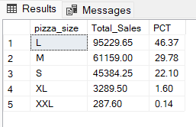

C . Best and worst seller in terms of Revenue, Quantity, Orders

a. Top 5 Best sellers by Revenue

select Top 5 pizza_name, Sum(total_price) As Total_Revenue From pizza_sales Group By pizza_name Order By Total_Revenue Desc;

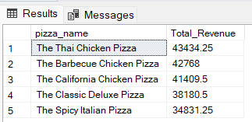

b. Bottom 5 sellers by Revenue

select Top 5 pizza_name, Sum(total_price) As Total_Revenue From pizza_sales Group By pizza_name Order By Total_Revenue Asc;

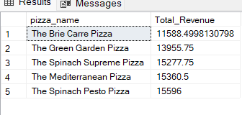

c. Top 5 Best sellers by Quantity

select Top 5 pizza_name, Sum(quantity) As Total_Quantity From pizza_sales Group By pizza_name Order By Total_Quantity DESC ;

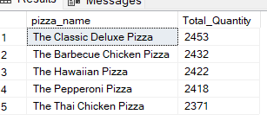

d. Bottom 5 sellers by Quantity

select Top 5 pizza_name, Sum(quantity) As Total_Quantity From pizza_sales Group By pizza_name Order By Total_Quantity ASC ;

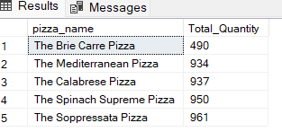

e. Bottom 5 sellers by Orders

select Top 5 pizza_name, Count(Distinct order_id) As Total_Orders From pizza_sales Group By pizza_name Order By Total_Orders ASC ;

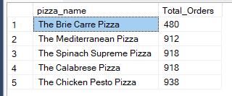

f. Tor 5 best sellers by Orders

select Top 5 pizza_name, Count(Distinct order_id) As Total_Orders From pizza_sales Group By pizza_name Order By Total_Orders DESC ;

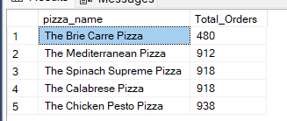

Overall Summary.

This document contains SQL queries used to analyze pizza sales data by evaluating key performance indicators (KPIs). The queries cover:

* **Total Sales Performance:** Includes total revenue, average order value, total pizzas sold, and total orders.
* **Order Trends:** Analyzes daily and monthly order trends to identify patterns.
* **Sales Distribution:** Evaluates sales percentages by pizza category and size.
* **Best & Worst Sellers:** Identifies the top and bottom-selling pizzas based on revenue, quantity, and total orders.

These queries provide insights into overall sales performance, customer preferences, and business trends, aiding in better decision-making for pizza sales optimization.